Name___________________________________________________________________ Date________________________

**Spring Break Assignment**

*The purpose of this assignment is to practice for the NYS Mathematics Exam*

*May 2, May 3 , & May 4*

*Attached are 22 multiple-choice questions and 4 short response questions. Please take it seriously. It will be graded, and count in your 4th marking period average.*

**Directions:** Answer all included questions. Show any and all work. You may attach loose leaf that you showed work on, if necessary.

* All multiple choice answers must be recorded on the answer sheet
* All work MUST be shown for the short answer questions
* Be sure to answer all questions completely
* Check your work
* Ask yourself, “Does this answer make sense?”
* Try your hardest!

Answer Sheet

1. _____________ 17. _____________
2. _____________ 18. _____________
3. _____________ 19. _____________
4. _____________ 20. _____________
5. _____________ 21. _____________
6. _____________ 22. _____________
7. _____________
8. _____________
9. _____________
10. _____________
11. _____________
12. _____________
13. _____________
14. _____________
15. _____________

(1) There are 150 boys at Tyvel’s school and 4% of them have a little brother. How many of the boys have a little brother?

1. 6
2. 8
3. 60
4. 80

(2) The table below lists the coordinates of four points.

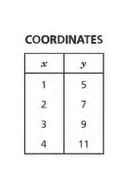

If x represents any number in the first column, which expression can always be used to find the value of y in the second column?

a. 5x

b. x + 2

c. x + 4

d. 2x + 3

(3) Look at this expression.

(6 + 3) 2 + 12 ÷ 2 x 3

What is the value of the expression?

1. 83
2. 18
3. 105
4. 78

(4) What is the value of y in the following equation:

6y + 8 = 80

a. y = 12

b. y = 14.7

c. y = 21.3

d. y = 10(5) A map of the Bronx’s is plotted on a coordinate grid.

* Jordan’s apartment is at (3, 5).
* The Foot Locker shoe store is at (3, 9).

How far is Jordan’s apartment from the shoe store?

1. 4 units
2. 9 units
3. 14 units
4. 20 units

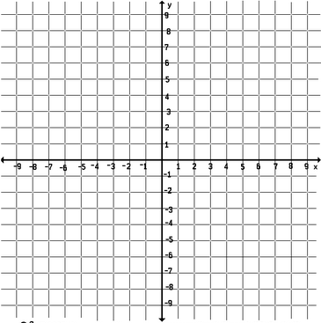

(6) Which expression is represented by the phrase “the square of y decreased by the quotient of 28 and 7?”

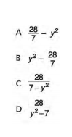

(7) Jayden owes his brother $100. He will repay his brother $5 each week. Which expression gives the amount in dollars Jayden will still owe his brother after *n* weeks?

1. 5 – 100n
2. 100 – 5n
3. 5n – 100
4. 100n - 5

(8) A group of students went on a field trip. There were 3 boys for every 4 girls in the group. If there were 20 girls, how many students in all went on the field trip?

1. 15
2. 27
3. 32
4. 35

(9) Jordan designs lights for movie sets. One movie set has a light control with 0 representing normal light. The lighting can be increased by increasing the number on the light control or decreased by decreasing the number on the light control. Which number on the light control would make the movie set the **darkest**?

1. 9
2. 4
3. -5
4. -7

(10) This number line shows the solution to an inequality for *x*, a rational number.   
 Description: https://renew.datawise-ed.com/DatawiseHome/TD/GetExamItemResource.aspx?itemID=143372&seqNum=1  
  
Which of these describes the solution?

1. x > 3
2. x < 3
3. x 3



1. x 3



(11) Jason has a coupon for $2.50 off any electronic book from an online book store. If the original price, in dollars, of an electronic book is p and the discounted price, in dollars, is d, which table shows the relationship between p and d?

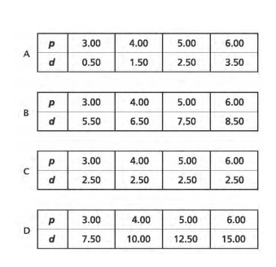

(12) Which pair of expressions below are equivalent?

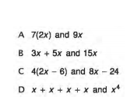

(13) An art teacher had 2/3 gallon of paint to pour into containers. If he poured 1/8 gallon of paint into each container until he ran out of paint, how many containers had paint in them, including the one that was partially filled?

a. 1

b. 3

c. 5

d. 6

(14) The coordinates of point F are (1, 0.5) and the coordinates of point G are (-1, -0.5). Which coordinate plane below correctly shows the locations of points F and G?

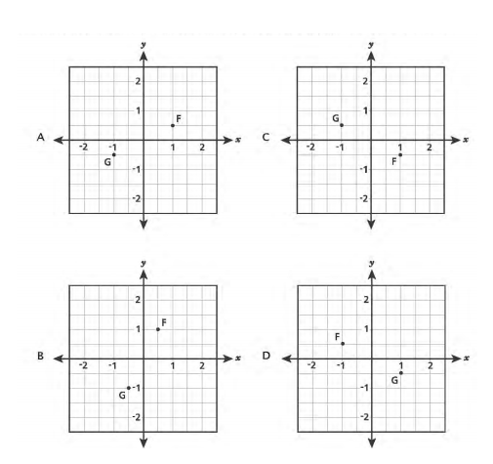

(15) Last year, Chesa made 32 one-cup servings of soup for a school party. This year, she will make two times the amount of soup that she made last year. How many gallons of soup will Chesa make this year?

a. 64

b .16

c . 4

d.2

(16) A shelf has four books on it. The weight, in pounds, of each of the four books on the shelf is listed below.

2.5, 3.2, 2.7, 2.3

Which inequality represents the weight, w, of any book chosen from the shelf?

a. w>2.3

b. w<2.4

c. w>3.2

d. w<3.3

(17)

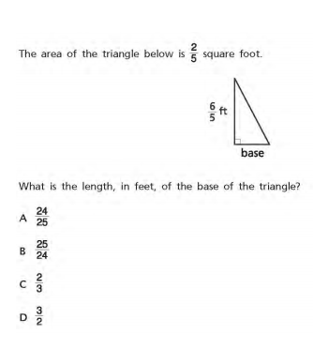

(18) Point M represents the opposite of – 1/2 and point N represents the opposite of 5/2. Which number line correctly shows points M and N?

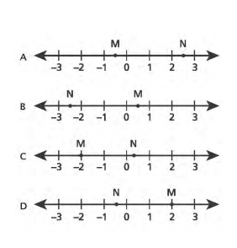

(19) The weight of an object on the moon, m, is about 1/6 of the object’s weight on Earth, e. Which equation represents the approximate weight of an object on the moon in terms of the objects weight on Earth?

a. m= 1/6 + e

b. m= e/6

c. m= 6 + e

d. m= 6e

(20) The table below shows different possibilities for the number of games a team would need to win to maintain a certain percentage of wins.

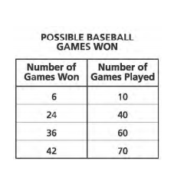

Which ratio of the number of games won to the number of games played could also be included in this table?

a. 18:20

b. 30:20

c. 18:30

d. 50:30

(21) Paul bought a package of 6 spiral notebooks for a total cost of $13.50. Which equation represents *p*, the cost, in dollars, of each notebook?

A *p* = 13.50 – 6

 B *p*=13.50 X 6

C *p* = 13.50 + 6

D *p* = 13.50 6

(22) The set of numbers 1, 7, 11, and 36 contains values for *m*. What value of *m* makes the equation below true?

4*m* + 8 = 36

A 1 B 7 C 11 D 36

**SHORT ANSWER**

(1) Jessica went shopping. She spent 60% of her birthday money on a new pair of sneakers. The sneakers originally cost $185.00, however she had a 25% off coupon.

a) What is the sale price of the sneakers?

**Show your work:**

Answer:_____________________________

b) How much birthday money did Jessica get in total?

**Show your work:**

Answer:_____________________________

(2) Jimmy, the class lizard, lost his tail. The class found that Jimmy’s tail grows 1/4 inch each week.

a) How many weeks will it take Jimmy’s new tail to grow 5 inches?

**Show your work:**

**Answer: _________________________**

(3) Andre and his father went to a movie at local theater AMC Movie Theater. Their local theater has a large theater screen that is much bigger than the typical movie screen.

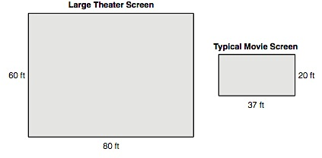

What is the ratio of the area of the large theater screen to the area of the typical movie screen?

**Show your work:**

**Answer: ____________________________**

(4) Alex put a fence around a rectangular yard that was 6 feet by 12 feet. The fence cost $1.50 for each foot. What was the total cost of the fence? **Show your work:**

**Answer: ____________________________**