Name_________________________________________________ Date_______________________
Math State Test
Practice Questions
Answer Sheet
Directions: Record your answers for Part A on the lines provided.
1. ______________
2. ______________
3. ______________
4. ______________
5. ______________
6. ______________
7. ______________
8. ______________
9. ______________
10. _____________
11. _____________
12.______________
13.______________
14. _____________
15._____________
16.______________

Part A: Multiple Choice
1. What is the x-coordinate of point P on the coordinate grid? 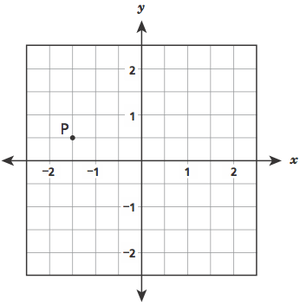
- -1 ½
- - ½
- ½
- 1 ½
2. Arnold’s entire workout consisted of 10 minutes of warm-up exercises, 25 minutes of lifting weights, and 15 minutes on the treadmill. What was the ratio of the number of minutes he lifted weights to the total number of minutes of his entire workout?
A. 1:1 B. 1: 2 C. 3:10 D. 5:8
3. A rectangular prism is shown below.
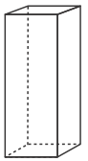
Which figure represents the net of the rectangular prism?
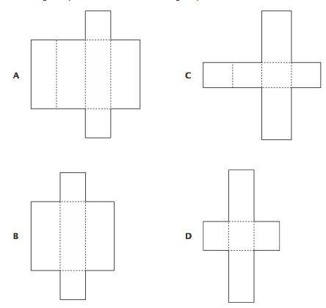
4. Wyatt hiked 6 miles in 2 hours. At this same rate, what is the total number of miles Wyatt could hike in 9 hours?
A. 3 B. 7 C. 21 D. 27
5. A punch recipe requires 2 cups of cranberry juice to make 3 gallons of punch. Using the same recipe, what is the amount of cranberry juice needed for 1 gallon of punch?
A. 3 cups B. 1 ½ cups C. 1 cups D. 2/3 cups
6. Omar has 2 3/4 cups of dough to make dumplings. If he uses 3/16 cup of dough for each 4 16
dumpling, how many whole dumplings can Omar make?

A. 13 B. 14 C. 15 D. 16

7. What is the solution of the equation below?
x + 8.63 = 11.001
A x = 19.631 B x = 10.138 C x = 3.471 D x = 2.371

8. A high-speed elevator can rise 480 feet in 30 seconds. Which expression represents the rate, in feet per minute, of the elevator?
A 480 × 30 B 480 ÷ 30 C 480 × 2 D 480 ÷ 2

9. What is the value of 5/ 6 ÷ 3/ 7?
A. 15/ 42 B. 18/ 35 C. 35/18 D. 42/ 15
10. Solve the equation below.
0.3r = 2.1
A r=0.7 B r=1.8 C r=7 D r=18
11. A group of students organized a car wash to raise money for a local charity. The students charged $5.00 for each car they washed. In 3 hours, they washed 12 cars. At that rate, how much money could they earn from washing cars for eight hours?
A $40.00 B $60.00 C $85.00 D $160.00
12. Kelly saves $5 every week. Which expression represents the amount of money, in dollars, Kelly will save in w weeks?
A. 5+w B. 5−w C. 5w D. 5/w
13. What is the greatest common factor of 56 and 92?
A. 2 B. 4 C. 7 D. 8
14. A company paid $48 for 2 cases of printer paper. Each case contained 12 packages of paper. Next month the company’s office manager needs to order 180 packages of the same paper. If the price per package does not change, what would be the total cost of next month’s order?
A $90 B $360 C $720 D $1,140
15. Which equation has the solution x = 2 ?
A 2x − 3 = 19 B 3x + 2 = 8 C 4x − 4 = −4 D 5x + 1 = 10
16. Which expression is equivalent to the expression below?
g + g + g + g + g + g
A 6+g B g6 C 6g D. g/6

Part B: Short Answers
1. Layla makes jewelry boxes containing drawers of equal size. The numbers of drawers in 3 different jewelry boxes and the corresponding total volumes of the drawers are shown in the table below.
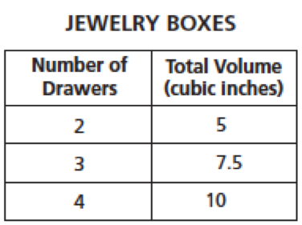
Write an equation for the relationship between the number of drawers in the jewelry box, d, and the total volume of the jewelry box, V.
Equation: V = ______________________________________
2. A leaky faucet is losing water and is filling a 5-gallon bucket every 20 hours. At that rate, how many gallons of water will the faucet leak in 48 hours?
Show your work:

Answer_________________________
3. A biologist counted the number of two types of salmon (Chinook and Steelhead) at a dam. He used the table below to record the number of salmon on different days.
Part A: On day 5, the biologist counted 16 Chinook. If the ratio of Chinook to Steelhead remained the same as on the previous four days, how many Steelhead should the biologist expect to count on day 5? Record your answer in the table below. 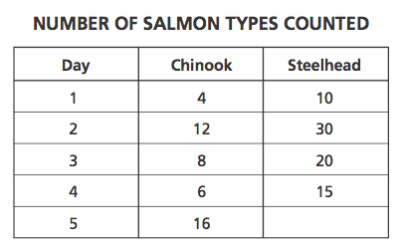
Show your work:

Answer:_____________________________________

Part B: Plot the salmon count data from the table on the coordinate grid below. Label each point with the day number.
