Name___________________________________________Date______________________
Class___________________________
Place Value HW #___________________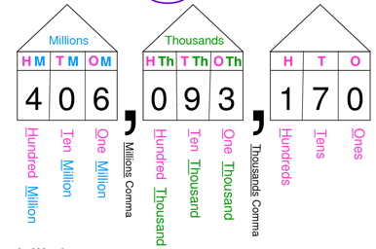
- Part A:
What digit is in the hundred thousands place in the number 7,296,831? ____________________

Part B:
What is the value of the digit in the hundred thousands place?___________________________

- Part A:
What digit is in the thousands place in the number 8,629,431? ___________________________

Part B:
What is the value of the digit in the thousands place?__________________________________

- Part A:
What digit is in the tens place in the number 76? _____________________________________

Part B:
What is the value of the digit in the tens place?______________________________________

- Part A:
What digit is in the hundreds place in the number 962,357? ____________________________

Part B:
What is the value of the digit in the hundred place?__________________________________
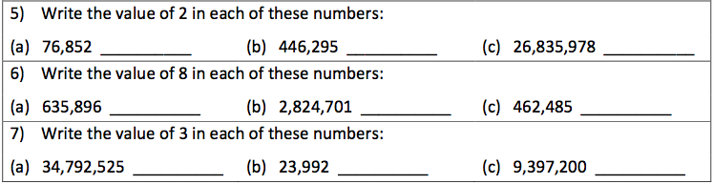

Directions: Use < , > , or = to compare the numbers.

8. 7,890 ________8,906

9. 56,793________ 45,645

10. 234,543________ 234,544

11. 543,697,798 ________ 543,675,677

12. 76,789_________6,785

