Name___________________________________________________ Date______________ Class_______
Fractions Homework
HW #_______
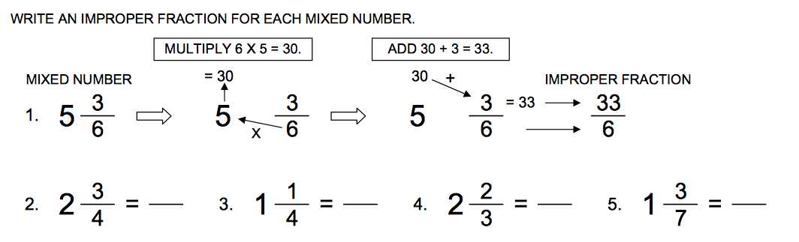

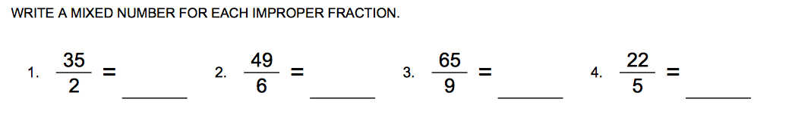_______

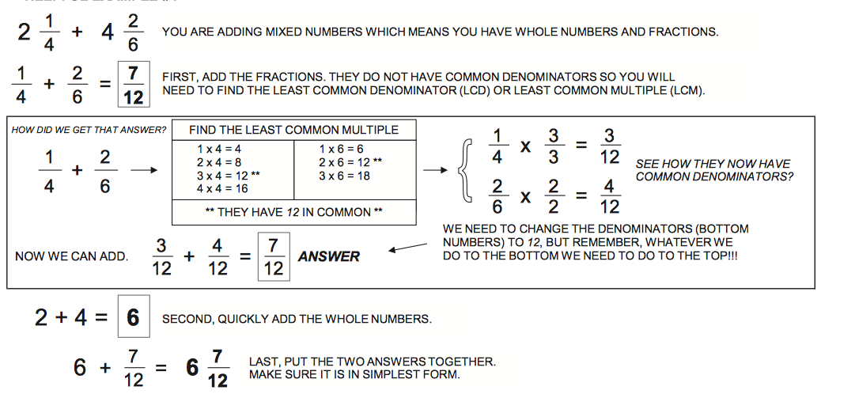

Directions: Solve each problem. Show ALL work. Write your answer in simplest form on the line.


  

