Unit: Fractions, Decimals & Percents
Learning Target: I can find the percent of a whole number.
Learning Objective: I can find the percent of a whole number.
Period 1: Mini Lesson: Parallel Teaching
- Teacher will represent the process of finding the percent of a whole number using a proportion for one example via Promethean, to introduce the learning target, while having students copy it down into their notebooks.
- Class notes will then be handed out.
- Teacher will review notes, only modeling the skill based completed first example from the notes sheet on the promethean.
  - How do I set up my proportion accurately?
  - How do I solve a proportion?
- Students will have 4-6 minutes to complete questions 1 and 2 on the back of the notes sheet. After 6 minutes, volunteers will be called on to share answers.
- Teacher will review creating a proportion to find the percent of a quantity based on student performance.
- Students must remember that percentages are out of 100 and so anything with a percent symbol goes over 100. The total amount must go across from 100 in the proportion.
Common Misconceptions:
- Proportion set up incorrectly
- Proportion solved incorrectly
Student Activity:
- Students will have 15-18 minutes to work on the basketball statistics sheet.
- After 8 minutes, teacher will stop to review the answers to two players on the front side of the paper.
- Once the questions have been reviewed, students will continue to work on the problems.
- Any table that finishes early will select one problem to display on a poster, showing all work and the correct answer.
- Students will be using their notes sheet as a guide to help them with the activity. An index card with the proportional setup will be given to students who are struggling.
Conclusion:
- NBA practice sheet will be collected and graded.

Period 2: Mini Lesson: Parallel Teaching
- Students will complete 2 percent skill problems as a Do Now (8 minutes).
- Answers will be reviewed.
- Students will be asked to look at the notes sheet again while the teacher models the second completed word problem example via promethean.
  - How do I set up my proportion accurately?
  - How do I solve a proportion?
- Students will have 6-8 minutes to complete questions 3 through 5 on the back of the notes sheet. After 8 minutes, volunteers will be called on to share answers.
- Teacher will review a word problem and creating a proportion to find the percent of a quantity based on student performance.
Common Misconceptions:
- Proportion set up incorrectly
- Proportion solved incorrectly

Student Activity:
- Students will complete the independent practice independently.
- After 8 minutes, teacher will stop to review questions 1 and 2.
- Once the questions have been reviewed, students will continue to work on the problems.
- Students will be using their notes sheet as a guide to help them with the activity. An index card with the proportional setup will be given to students who are struggling.
Conclusion:
- Teacher will review number 6 with the students.
- Student volunteers will be called to the promethean to review the rest of their answers.
- Students should check their own work.

Homework: (see attached)
607 | 607 | 608 | 608
Mrs. Maljevic | Ms. Goodheart | Mrs. Maljevic | Ms. Goodheart
Modou  Omer  Aniya | Jerry  Janleo  Luis | Devonique  Devine  Jayden | Erica  Jerick  John
Jaquan  Darius  Justin | Natasha  Elijah  Karielis | Aaron  Delmary  Alejandra | Xavier  Keidria  Angela
Dev  Pelkin  Alejandro | Melissa  Lyvia  Armon | Shariya  Leah  Yamilex | Arianna  Kaitland  Jah- Seani
Ignacio  Lynette | Sandra  Santi  Uriel  Amran | Elijah  Christian  Devin | Serena  Justin  Kelvin  Mia

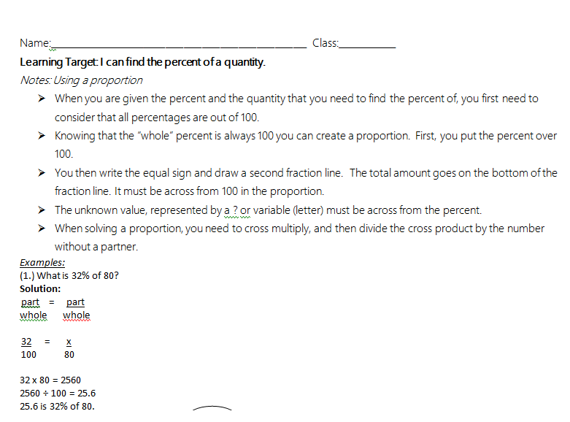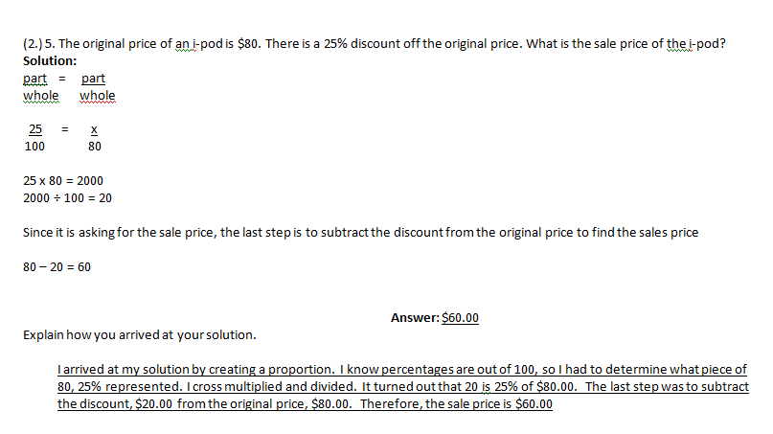

Directions: Solve using a proportion:

1. What is 32% of 60?

Answer:__________________________
2. What is 20% of 141?

Answer:__________________________
3. The library surveyed 180 people about their favorite type of movie. If 40% of the people chose action, how many people chose action?

Answer:__________________________
4. The original price of a pair of jeans is $32. The discount is 15% off the original price. What is the amount of the discount?

Answer:__________________________
5. The original price of a bicycle is $120. There is a 30% discount off the original price. What is the sale price of the bicycle?

Answer:_________________________
Name:________________________________________ Date:______________ Class:_____________
Finding the Percent of a Number
The table shows the number of free throws shot made by NBA players during the post season.
Directions: Find the total number of free throws each player successfully made.
Percent of shots made | Proportion/Show your work | Number of shots Made
S. Curry:
75% of 160 attempted shots
J. Butler:
60% of 145 attempted shots
K. Love:
80% of 125 attempted shots
R. Jackson 55% of 80 attempted shots
E. Gordon
85% of 140 attempted shots

Directions: Answer the following questions based on this chart:

(1) Who made the highest percentage of free throws in the post season? ________________________

(2) Who made the highest number of free throws in the post season? ___________________________

(3) Who made the lowest percentage of free throws in the game? ________________________

(4) Who made the fewest number of free throws in the post season? ___________________________

(5) If K. Love had made 100% of his free throws, how many total free throws would he have made? ____________________________

(6) If S. Curry had made 0% of his free throws, how many free throws would he have made? ____________________________

(7) K. Caldwell-Pope attempted 110 shots. He missed 33% of his attempted shots. How many total free throws did he successfully make?
Show your work:

Answer:_______________________________
Name__________________________________ Date_____________ Class________________
Directions: Solve the following word problems using a proportion. Round to nearest whole number!

- Christian found a new t-shirt that cost $32.00. He has a 20% off coupon. What is the sale price of the t-shirt?
Setup | Work | Answer

- Jerick wants a new ipod that cost $130.00. He has a coupon for 25% off the original price. What is the sale price of the ipod?
Setup | Work | Answer

- Mr. Kouvatsos is going to order textbooks. 150 textbooks cost $225.00. He has a discount of 25% off the total cost. What is the sale price of the textbooks?
Setup | Work | Answer

- Mr. Warnock has $50.00 to purchase pencils with. He spent 70% of the money on pencils. How much money did the pencils cost?
Setup | Work | Answer

- Modou received notice that his monthly health care rate will increase 20% next year. If Modou currently pays $150 per month for health care, by what amount will his rate increase next year?
Setup | Work | Answer
- Stephani is a news anchor. She works 55 hours a week, but she is only on-air about 18% of those hours. Approximately how many hours is Sarah on-air each week?
Setup | Work | Answer

- A baseball pitcher won 80% of the games he pitched. If he pitched 35 ballgames, how many games did he win?
Setup | Work | Answer

- A student earned a grade of 80% on a math test that had 20 problems. How many problems on this test did the student answer correctly?
Setup | Work | Answer

- Natasha found a wrecked Trans-Am that she could fix. She bought the car for 65% of the original price of $7200. What did she pay for the car?
Setup | Work | Answer

- Dev earns $12,800 a year. About 15% is taken out for taxes. How much is taken out for taxes?
Setup | Work | Answer
Name:________________________________________ Date:___________ Class:_____________
Percents HW
1. Choose the best score on a quiz
A. 15 out of 25 C. 8 out of 14
B. 25 out of 45 D. 30 out of 40

2. Mrs. Brynes gave a test. The student that performed best in her class earned a 70%. There were 40 questions on the test. How many total questions did the students answer correctly?
Show your work:

Answer:_________________________
3. Armon asked 55 students in his class if they had a smart phone. 34 said yes. Do more than 50% of the students have a smart phone? ________________ How do you know? _______________________________________________________________________________________________________________________________________________________________________________________________________________________________________________________________
b. Amran said that 14 out of 38 students in his class have a smart phone. Do more than 50% of the students have a smart phone? ________________ How do you know? _____________________________________________________________________________________
__________________________________________________________________________________________________________________________________________________________________________

4. What is 25% of 60?
Show your work:

Answer:_______________________________
5. What is 30% of 90?
Show your work:

Answer:_______________________________
6. What is 75% of 20?
Show your work:

Answer:______________________________

