Unit: Fractions, Decimals & Percents
Learning Target: I can find the percent given the part and a whole
Learning Objective: I can find a missing percent given the part and the whole using a proportion.
Period 1: Students will be taking Mastery Quiz 2 for Unit 2
Period 2: Mini Lesson: Parallel Teaching
- Class notes will be handed out.
- Teacher will review notes, modeling the completed examples from the notes sheet via Promethean.
  - How do I set my proportion accurately?
  - How do I solve a proportion?
- Students will have 4-6 minutes to complete questions 1,2 and 3 on the back of the notes sheet. After 4 - 6 minutes, volunteers will be called on to share answers.
- Teacher will review creating a proportion to find the missing percent.
- Students must remember that percentages are out of 100, so when the percent is missing, the ? or the variable goes on top of 100.
Common Misconceptions:
- Incorrectly setting up the proportion
- Incorrectly solving the proportion
Student Activity:
- Students will have 15-18 minutes to work on the basketball statistics sheet.
- After 8 minutes, teacher will stop to review the answers to the first two players on the front side of the paper.
- Once the questions have been reviewed, students will continue to work on the problems.
- Any table that finishes early will select one problem to display on a poster, showing all work and the correct answer.
- Students will be using their notes sheet as a guide to help them with the activity. An index card with the proportional setup will be given to students who are struggling.
Conclusion:
- NBA practice sheet will be collected and graded.
Homework:
- attached
607 | 607 | 608 | 608
Mrs. Maljevic | Ms. Goodheart | Mrs. Maljevic | Ms. Goodheart
Modou  Omer  Aniya | Jerry  Janleo  Luis | Devonique  Devine  Jayden | Erica  Jerick  John
Jaquan  Darius  Justin | Natasha  Elijah  Karielis | Aaron  Delmary  Alejandra | Xavier  Keidria  Angela
Dev  Pelkin  Alejandro | Melissa  Lyvia  Armon | Shariya  Leah  Yamilex | Arianna  Kaitland  Jah- Seani
Ignacio  Lynette | Sandra  Santi  Uriel  Amran | Elijah  Christian  Devin | Serena  Justin  Kelvin  Mia
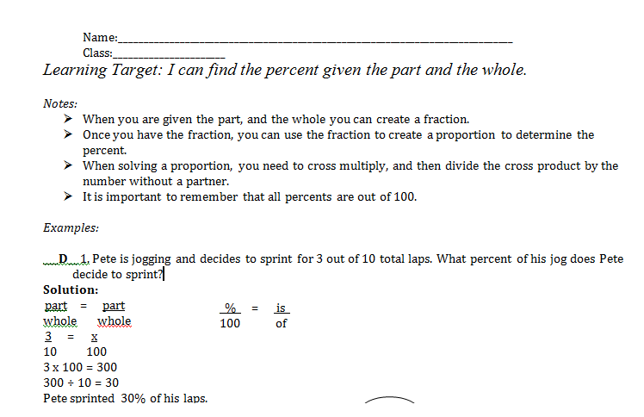

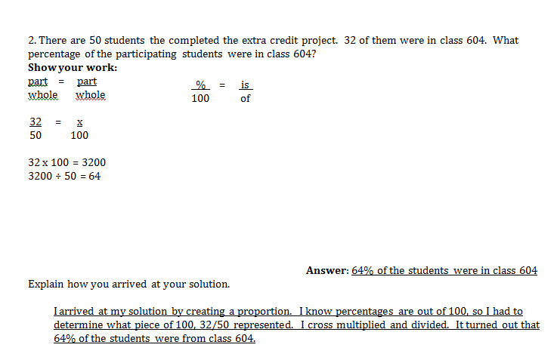
1. 13 out of 25 is equal to what percent?
Show your work:

Answer:____________________
2. 42 is what percent of 150?
Show your work:

Answer:____________________
3. 18 is what percent of 24?
Show your work:

Answer:____________________

Name:______________________________ Date:__________________ Class:_____________
The chart below shows the number of shots players made in the game, compared to the number of shots they attempted. Determine the percentage of shots that each player made.
Player & Number of shots made | Proportion/Work | Percent of shots made
Carmelo Anthony
Shots made: 32
Shots attempted: 40
Amar’e Stoudemire
Shots made: 15
Shots attempted: 60
Iman Shumpert
Shots made: 16
Shots attempted: 20
Jason Smith
Shots made: 12
Shots attempted: 16
(1) Who scored the highest percentage of shots? ________________________________________________________________
(2) Who made the highest number of shots? ________________________________________________________________
(3) Who scored the lowest percentage of shots? _______________________________________________________________

(4) Who made the lowest number of shots?_______________________________________
(5) At MSG there were 850 males present. There were 1,000 people there. What percentage of the people were male?
Show your work:

Answer:______________________________________________________________
(6) Based on the information in question 2, what percentage of the people in attendance were female?
Show your work:

Answer:______________________________________________________________
Name:___________________________________________ Class:___________
Finding the Percent HW
1. On Sunday, 125 people visited the zoo. 80 of the 125 people were children. What percentage of the visitors were children?

____% of the people at the zoo on Sunday were children.
2. There are 640 students attending middle school. Of those students, 320 come by car. What percentage of students come by car?

_______% of students come by car each day.
3. There are 25 teachers in the math department. Of those teachers, 24 live in New York State. What percentage of the math teachers do not live in New York State?

_____% do not live in NYS

