Name____________________________________________ Date____________________ B

Mr. Warnock and Mr. Kouvatsos are going to see the Giants vs. Green Bay game at MetLife stadium. They had extra tickets and invited friends to come and see the game. Before the game, Mr. Warnock and Mr. Kouvatsos purchased appetizers. The order consist of 108 boneless buffalo wings, 72 loaded potatoes, and 63 soda’s. They want to create an even amount of platters with buffalo wings, loaded potatoes and sodas.
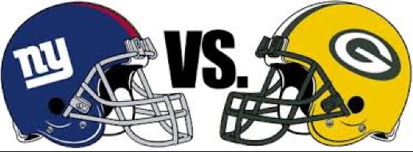

- What is the greatest number of platters Mr. Warnock and Mr. Kouvatsos can make?
Show your work:

Answer:_____________________________
- How many boneless buffalo wings, loaded potatoes, and sodas are in each platter?
Show your work:

Answer: Boneless Buffalo Wings ___________ Loaded Potatoes ____________ Sodas __________

3. Explain in complete sentences how you arrived at your answer to part 2, using your math vocabulary.

____________________________________________________________________________

____________________________________________________________________________

____________________________________________________________________________

____________________________________________________________________________

____________________________________________________________________________

Name____________________________________________ Date____________________ B

Mr. Warnock and Mr. Kouvatsos are waiting for a train at the Metro North Train Station. The two trains that are going to Metlife Stadium are train A and train B. Mr. Warnock gets on train A at the same time Mr. Kouvatsos gets on train B. The trains begin to move as soon as your buckled into your seats.

- Figure out the number of minutes that will pass before Mr. Warnock and Mr. Kouvatsos are both at the Metro North Train Station again if train A takes 5 minutes to go around once and train B takes 2 minutes to go around once.
Show your work:

Answer: ______________________________________
2. What is the time Mr. Warnock and Mr. Kouvatsos will both be at the train station? Both of the Trains left at 12:00.
Show your work:

Answer:______________________________________________
- If the ride continues, is it possible that Mr. Warnock and Mr. Kouvatsos will be at the train station at 12:40?
Show your work & Explain:

Answer:_______________________________________________
It is ____________________________ that Mr. Warnock and Mr. Kouvatsos will be at the train station at 12:40 because__________________________________________________________ ____________________________________________________________________________________________________________________________________________________________________________________________________________________________________.

