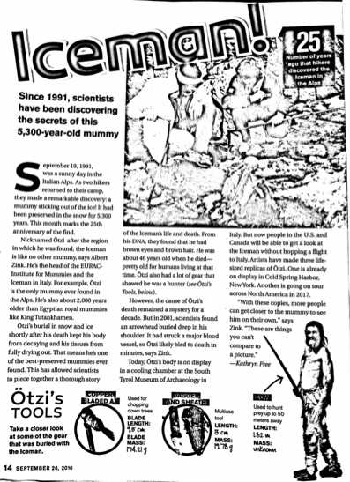

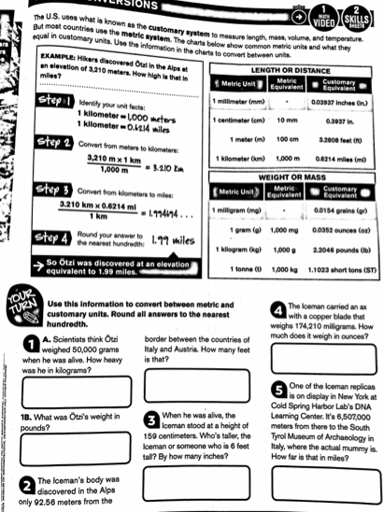

Name___________________________________________________ Date_______________
Iceman Article Questions Class______________

Part A:
- What is the central idea of the article?

_________________________________________________________________________________________________________

_________________________________________________________________________________________________________

_________________________________________________________________________________________________________

_________________________________________________________________________________________________________

_________________________________________________________________________________________________________

_________________________________________________________________________________________________________

- Find 2 supporting details that best support the central idea?

_________________________________________________________________________________________________________

_________________________________________________________________________________________________________

_________________________________________________________________________________________________________

_________________________________________________________________________________________________________

_________________________________________________________________________________________________________

_________________________________________________________________________________________________________

- What is the author’s perspective about this discovery? Use details from the article to support your answer.

_________________________________________________________________________________________________________

_________________________________________________________________________________________________________

_________________________________________________________________________________________________________

_________________________________________________________________________________________________________

_________________________________________________________________________________________________________

_________________________________________________________________________________________________________

- What is the impact of this discovery on society? How does it affect people? The world?

_________________________________________________________________________________________________________

_________________________________________________________________________________________________________

_________________________________________________________________________________________________________

_________________________________________________________________________________________________________

_________________________________________________________________________________________________________

_________________________________________________________________________________________________________

Part B:
Summarize the article in your own words. (use at least 25- 30 words)

_________________________________________________________________________________________________________

_________________________________________________________________________________________________________

_________________________________________________________________________________________________________

_________________________________________________________________________________________________________

_________________________________________________________________________________________________________

_________________________________________________________________________________________________________

_________________________________________________________________________________________________________

_________________________________________________________________________________________________________

_________________________________________________________________________________________________________

_________________________________________________________________________________________________________

_________________________________________________________________________________________________________

_________________________________________________________________________________________________________

_________________________________________________________________________________________________________

_________________________________________________________________________________________________________

