Name_________________________________ Date___________ Class______
Test Prep
Part A: Multiple Choice

- ___________

- ___________

- ___________

- ___________

- ___________

- ___________

- ___________

- ___________

- ___________

- ___________

Part A: Multiple Choice
1. The length of a rectangular parking lot at the airport is 2/3 mile. If the area is ½ square mile, what is the width of the parking lot?
A. 1/3 mile B. ¾ mile C. 1 1/6 mile D. 1 1/3 mile
2. The table below shows the number of tea bags needed to make different amounts of iced tea.
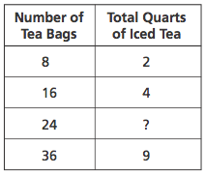

What is the total number of quarts of iced tea that can be made with 24 tea bags?
A. 5 B. 6 C. 7 D. 8

3. Which number best represents the location of point E on the number line below? E
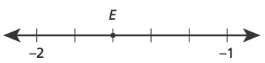

A −1.8 B −1.6 C −1.5 D −1.3
4. Machines S and T were both cleaned this week.
Machine S is cleaned every 12 weeks.
Machine T is cleaned every 8 weeks.
What is the fewest number of weeks that will pass before both machines are cleaned again in the same week?
A.16 B.24 C. 36 D. 48
5. In Ms. Perron’s class, 75% of the students are boys. There are 18 boys in the class. What is the total number of students in Ms. Perron’s class?
A6 B 14 C 24 D 57
6. Which expression is equivalent to 5(d + 1) ?
A 5d+5 B 5d+1 C d+5 D d+6
7. Which situation can be represented by the expression 1.3x?
A. the total cost of an item that is x dollars more than $1.30
B. the area of a rectangle with side lengths 1.3 and x
C. the amount of change when $1.30 is used to pay for an item costing x dollars
D. the number of square feet in each lot when 1.3 acres is partitioned into x equal sections

8. Which expression is modeled by the diagram below?
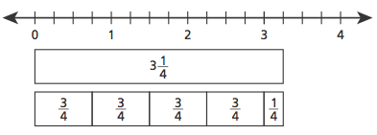
9. What is the surface area of the triangular prism?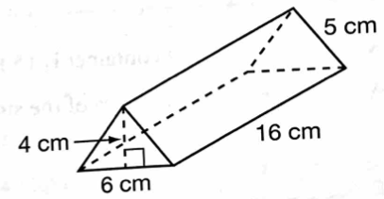
A. 264 cm B. 280 cm C. 312 cm D. 324 cm

10. The base of a right rectangular prism has an area of 173.6 square centimeters and a height of 9 centimeters. What is the volume, in cubic centimeters, of the right rectangular prism?
A. 182.6 B. 781.2 C. 14,061.6 D. 1,562.4
Part B: Short Answer

1. Timothy went to a baseball game. After the game, he wanted to ride the bus home. The red line and the blue line buses both stop at the stadium.

A red line and a blue line bus both left the stadium at 4:00 p.m.
Red line buses were scheduled to leave the stadium every 6 minutes.
Blue line buses were scheduled to leave the stadium every 8 minutes.

If the buses run on schedule, when is the next time a red line and a blue line bus will leave together?
Show your work.

Answer _________ p.m.
2. A box in the shape of a right rectangular prism has a length of 8.5 inches, a width of 4.5 inches, and a height of 3.75 inches. What is the volume, in cubic inches, of the box? Do not round your answer.
Show your work.

Answer _______________ cubic inches

3. Graph the polygon ABCDEF, which has vertices at the following coordinates, on the coordinate grid below.
A(−4, 7), B(6, 7), C(6, −2), D(−8, −2), E(−8, 3), F(−4, 3)
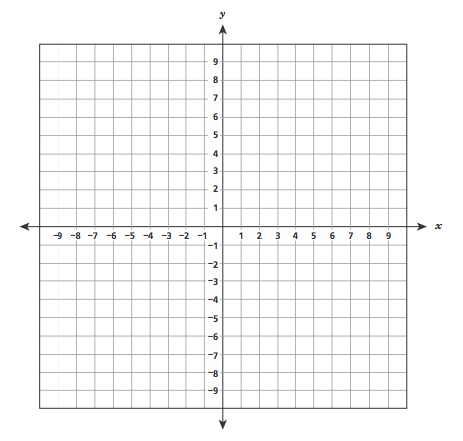
What is the perimeter of polygon ABCDEF?

Answer _______________ units

