**Cupcake Delights’s Decisions**

**Part A:**

Ms. Maljevic goes to Warnock’s Place and to Casal’s Food Mart to purchase items needed to bake cupcakes. Which store has the best deal? Check the unit rate with the best deal.

|  |  |  |  |  |
| --- | --- | --- | --- | --- |
| Warnock’s Place | Casal’s Food Mart |  | Show your work  Warnock’s Place Casal’s Food Mart | |
| 15 lbs. of vanilla chocolate chips for $15.30 | 10 lbs. of vanilla chocolate chips for $20.00 | Screen Shot 2016-02-12 at 8 |  |  |
| 5 oz. of chocolate chips for $20.50 | 6 oz. of chocolate chips for $3.60 | Screen Shot 2016-02-12 at 8 |  |  |
| 10 lbs. of flour for  $1.35 | 4 lbs. of flour for $28.40 | Screen Shot 2015-01-08 at 6 |  |  |
| 12 oz. of rainbow sprinkles for  $ 24.60 | 7 oz. of rainbow sprinkles for  $35 .00 | Screen Shot 2016-02-12 at 10 |  |  |

**Part B:**

**Directions:** According to the unit rates in Part A, find the equivalent rates to each item above.

1. Ms. Maljevic needs to purchase 35 oz. of vanilla chocolate chips to bake her cupcakes. What is the total amount she is going to spend on the vanilla chocolate chips?

**Show your work:**

Answer________________________

2. Ms. Maljevic needs to purchase 20 oz. of chocolate chips to bake her cupcakes. What is the total amount she is going to spend on the chocolate chips?

**Show your work:**

Answer________________________

3. Ms. Maljevic needs to purchase 50 oz. of flour to bake her cupcakes. What is the total amount she is going to spend on the flour?

**Show your work:**

Answer________________________

4. Ms. Maljevic needs to purchase 13 oz. of rainbow sprinkles to bake her cupcakes. What is the total amount she is going to spend on rainbow sprinkles?

**Show your work:**

Answer_______________________

**Part C:**

Ms. Maljevic reviews her food shopping credit card statement for the month and sees the following transactions. She says they are ordered from least to greatest. Is she correct? Explain why or why not.

Macintosh HD:Users:admin:Desktop:Screen Shot 2016-11-04 at 1.47.19 PM.png

**Ms. Maljevic**

**Account Number: 123456789**

Transaction Date Transaction Amount



12/21/2016 Warnock’s Place -$24.00

12/22/2016 Berenson’s Restaurant Mania -$36.50

12/23/2016 Trader Joe’s $ 112.75

12/24/2016 K- Mart- Eggs $37.25

__________________________________________________________________________________

__________________________________________________________________________________

____________________________________________________________________________________________________________________________________________________________________________________________________________________________________________________________________________________________________________________________________________________________________________________________________________________________________________________________________________________________________________

**Cupcake Delights’**

**Part D:**

Nikoleta ate some cupcake’s with her family at Cupcake Delights. Nikoleta needs to convert her fractions of the amount of cupcake’s her and her family ate into decimals. Show your work below to convert the cupcaks from fractional amounts to decimals.

Cupcake 1 Cupcake 2

**1/4** **3/8**

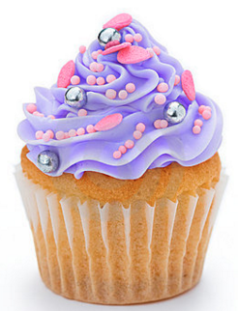 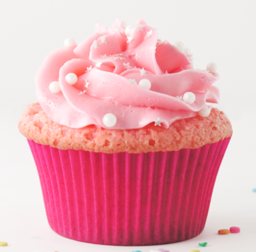

Cupcake 1: ____________ Cupcake 2: ______________

**Part E:** Nikoleta decided to eat at Goodheart’s Good Eats for her birthday party. She ordered 4 cupcake batches with different toppings. Nikoleta wants to order the prices of each cupcake batch by their fractional forms from **greatest to least.**

Cupcake Batch 1 Cupcake Batch 2 Cupcake Batch 3 Cupcake Batch 4

   

**$12.05 $12.25 $12.50 $12.20**

**Greatest Least**

________________ ________________ ________________ ________________

**The Price is Right**

**Part F:**

Sandra decided to have some friends and family get together for a breakfast at Cupcake Delights.

What is the best deal for each item? **Show your work below.**

 

12 vanilla cupcake with purple sprinkles for $19

8 vanilla cupcakes with pink sprinkles for $20

**Answer:____________________________________ Answer:____________________________________**

Which order of muffins is the best deal? Justify your answer.

________________________________________________________________________________________________________________________________________________________________________________________________________________________________________________________________________________________________________________________________________________________________________________________________________________________________________________________________________________________________________________________________________________________________________________

**Part G:**

If Sandra wants to buy three pitchers of coffee for every 4 people and there are 30 people at the café, how many pitchers will she need to purchase?

**Show your work below.**

Answer:______________________________________