**Owner Goodheart’s Food Decisions**

1. Ms. Goodheart needs to get food for the meals at her cafe. She shops for a few hours at Maljevic’s Super Store and then heads to the cashier to purchase some items. She then heads to Berenson’s Restaurant Mania where she finds some better deals and heads back to Maljevic’s Super Store to return some of the items. During the day Ms. Goodheart made the following transactions:

1. Ms. Goodheart purchases 200 lbs of chopped meat from Maljevic’s Super Store for $268.00.
2. Ms. Goodheart purchases 100 lbs of mozzarella cheese for $95.00 from Berenson’s Restaurant Mania
3. Ms. Goodheart returns 45 lbs of lettuce she bought that cost $105.75 from Maljevic’s Super Store.
4. Ms. Goodheart purchases 75 lbs of tomatoes for $135.00 from Berenson’s Restaurant.
5. Ms. Goodheart returns 100 hamburger rolls for $175.00 from Maljevic’s Super Store

Part A: Use the chart below to record each transactions unit rate.

|  |  |
| --- | --- |
| Item | Unit Rate |
|  |  |
|  |  |
|  |  |
|  |  |
|  |  |

**Part B:**

**Directions:** According to the unit rates in Part A, find the equivalent rates to each item above.

1. Ms. Goodheart needs to purchase 220 lbs. of chopped meat for meals at her cafe. What is the total amount she is going to spend on the chopped meat?

**Show your work:**

Answer________________________

2. Ms. Goodheart needs to purchase 114 lbs. of mozzarella cheese for meals at her cafe. What is the total amount she is going to spend on the mozzarella cheese?

**Show your work:**

Answer________________________

3. Ms. Goodheart needs to purchase 95 lbs. of lettuce for meals at her cafe. What is the total amount she is going to spend on the lettuce?

**Show your work:**

Answer________________________

4. Ms. Goodheart needs to purchase 76 lbs. of tomatoes for meals at her cafe. What is the total amount she is going to spend on tomatoes?

**Show your work:**

Answer_______________________

Part C. Ms. Goodheart reviews her food shopping credit card statement for the month and sees the following transactions. She says they are ordered from least to greatest. Is she correct? Explain why or why not.



**Ms. Goodheart**

**Account Number: 123456789**

Transaction Date Transaction Amount



12/21/2016 Shop Rite- 6 Onions -$6.69

12/21/2016 Shop Rite- Pepper -$1.99

12/21/2016 Trader Joe’s purchase- 1 gallon of Pickles $6.98

12/21/2016 K- Mart- Eggs $3.99

__________________________________________________________________________________

__________________________________________________________________________________

____________________________________________________________________________________________________________________________________________________________________________________________________________________________________________________________________________________________________________________________________________________________________________________________________________________________________________________________________________________________________________

__________________________________________________________________________________________________________________________________________________________________________________________________________________________________________________________________________________________________________________________________________________________________________________________________________________________________________________________________________________________________________________________________________________________________________________________________________________

**Pizza Pizza**

2. Devine ate some pizza with his family in Goodheart’s Good Eats.

**Part A:** Devine needs to convert his fractions of the amount of pizza him and his family ate into decimals. Show your work below to convert the pizzas from fractional amounts to decimals.

**ROUND YOUR DECIMALS TO THE NEAREST HUNDREDTH!!!!!!**

Pizza 1 Pizza 2 1**/6** **3/9** 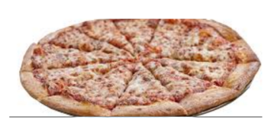

Pizza 1: ____________ Pizza 2: ______________

**Part B:** Devine decided to eat at Goodheart’s Good Eats for his birthday party. He ordered 4 pizza pies with different toppings. Devine wants to order the prices of each pizza by their fractional forms from **least to greatest.**

Pizza 1 Pizza 2 Pizza 3 Pizza 4

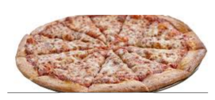 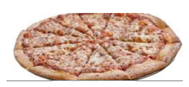 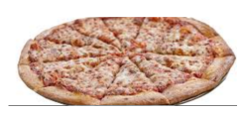 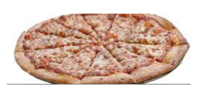

**$12.05 $12.25 $12.50 $12.20**

**Least Greatest**

**________________ __________________ __________________ ______________**

**The Price is Right**

3. Shariya decided to have some friends and family get together for a breakfast at Goodheart’s Good Eats.

**Part A**. What is the best deal for each item? **Show your work below.**

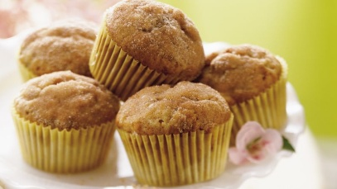 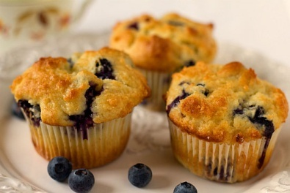 1 dozen muffins for $19.68

8 muffins for $20.88

**Part B**

Which order of muffins is the best deal? Justify your answer.

__________________________________________________________________________________________________________________________________________________________________________________________________________________________________________________________________________________________________________________________________________________________________________________________________________________________________________________________________________________________________________________________________________________________________

If Shariya wants to buy three pitchers of coffee for every 3 people and there are 27 people at the café, how many pitchers will she need to purchase?

**Show your work below.**

________________ pitchers